RMIT PLACELAB MELBOURNE
‘Co-Lab for Cardigan –Envisioning our street together’
Session 1: WEDNESDAY 20TH SEPTEMBER 2023 / 4:00-6:00 pm
Session 2: THURSDAY 21ST SEPTEMBER 2023 / 9:30-11:30 am

EVENT RUN ORDER
 | Session 1  Wednesday 20 | Session 2  Thursday 21
(30”) Registrations – Mingle | 3:30 – 4:00 | 9:00-9:30
(5”) Introduction (Acknowledgement - Place Lab – Innovation Precinct) | 4:00 – | 9:30 -
(5”) Cardigan Commons
(5”) Re/Wild/ing | - 4:15 | - 9:45
(5”) Icebreaker dynamic | 4:15 – 4:20 | 9:45 - 9:50
(5”) Section assignment – Explanation of Workshop | 4:20 – 4:25 | 9:50 – 9:55
(15”) Walkthrough Cardigan St | 4:25 – 4:40 | 9:55 – 10:10
(10”) Instructions | 4:40 – 4:50 | 10:10 – 10:20
(60”) Workshop | 4:50 – 5:50 | 10:20 – 11:20
TOTAL >> 1:50”
Timing:

Venue: RMIT PlaceLab Melbourne
17-21 Cardigan St
Carlton VIC 3053
Overview: RMIT PlaceLab extends a warm invitation to you to participate in “Co-Lab for Cardigan - envisioning our street together”. This is a fun, interactive, and purposeful collaborative experience to re-imagine how our city can be, through a place-based approach.
We are inviting community, subject professionals and other stakeholders to come together and answer the question, “What’s the street of your wildest dreams?” We are throwing away the idea of what a street is, and asking, what could it be?
https://www.eventbrite.com.au/e/rmit-placelab-co-lab-for-cardigan-envisioning-our-street-together-tickets-687070635767

Audience: Community (Targeted) Event, General Audience*
*Please ensure presentations are catered to a general audience.

Floor Plan:
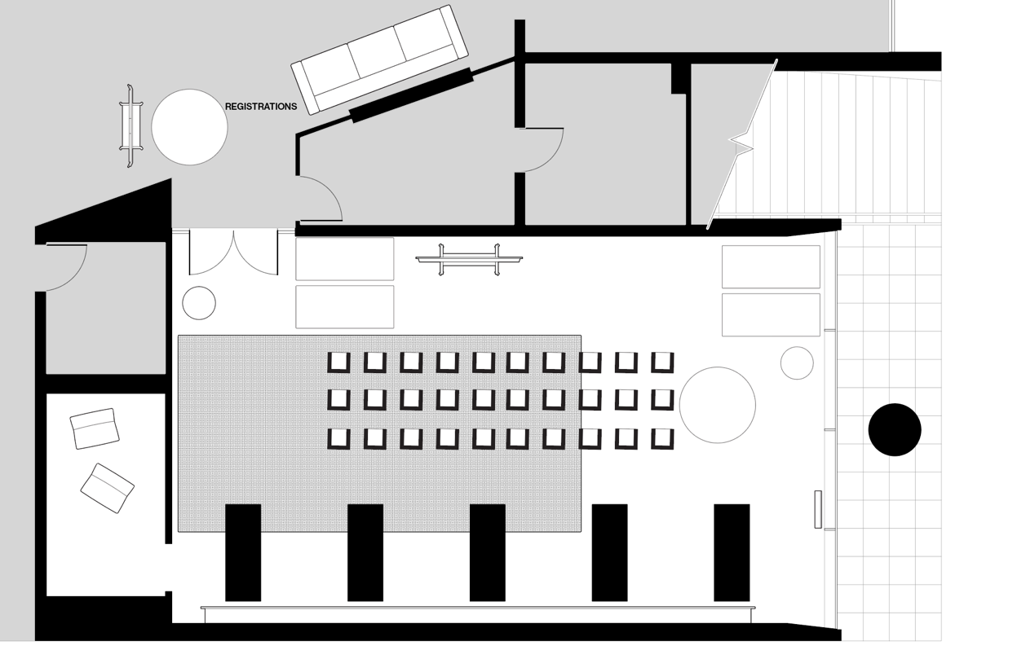

Roles and Responsibilities:
 | Session 1  Wednesday 20 | Session 2  Thursday 21
Registrations:  Assign Name tags with colours according to groups | Frances  Luke + Paloma | Luke  Paloma
Introduction:  Acknowledgement - Place Lab – Innovation Precinct | Brock | Brock
MC:  Welcome and overview of Cardigan Commons Research | Cherese | Cherese
Rewilding | LA Academics | LA Academics
Workshop Explanations:  Walkthrough  Timekeeper  Observation Notes | Paloma | Paloma
Facilitators:  - help guide the discussion (following prompts)  - Photos of Iterations of design  - Observation notes | Heike  Brendt  Maude  Brock | Heike  Brendt  Brock  Cherese
Photo | Theresa | --
Videos | Paloma | Paloma

BUMP IN & SET UP
TIME | ACTION | RESPONSIBILITY
10:30 am | Elements for set up prior  - Map of Cardigan Street on Monolith with pictures and sections  - Tables and seats according to floor plan  - Presentations tested on screens  - Digital signage  - Lighting adjusted for event.  - Holding slide for digital screen  - Table with catering (Water and mugs) | RMIT PlaceLab
1:30 pm | - Streat drop off  - TEAM: MAKE SURE YOU TAKE A BREAK
2:00 pm | Meet up and review of event run order and role responsibilities  RMIT PlaceLab staff onsite.  Bump In & Set Up to include:  - Digital Screen & Surface Hub Content and Holding Slides installed.  - A-Frame set up for wayfinding  - Registration table with catering set up outside space. (Printed copy of attendees printed with their assigned colour/group)  - Books to read in the meantime  - Workshop tables with Instructions, whiteboard markers, and magnets  - Set up notification of filming and photography happening in space.  - Lofi beats music | RMIT PlaceLab
3:00 pm | - Digital Screen & Surface Hub Content and Holding Slides tested.  - Presenters and facilitators onsite  - Photographer Theresa on site to be briefed. | RMIT PlaceLab
3:30 pm –  4:00 pm | Doors open for guest arrivals.  - RMIT PlaceLab Team in position.  - RMIT PlaceLab Team briefing participants upon arrival of;  1. Confirming registration  2. Photography/Videography – opt out option.  3. Any accessibility requirements.  - Photographer in action.  - REGISTRATIONS and name tags according to assigned group + include pronouns (if they want) | RMIT PlaceLab
EVENT BEGINS
4:00 pm -  4:15 pm | - Welcome to all  Acknowledgement of Country.  RMIT PlaceLab initiative  Innovation Precinct  Cardigan Commons Research  (BROCK) – 5 MIN  - Housekeeping  One Word  Introduction to academics  (M.CHERESE) – 5 MIN  - Rewilding – Spontaneous Ecology. Mention the power point  ACADEMICS – 5MIN | Brock + Cherese + LA Academics (Brendt + Maude + Heike)
4:15 pm -  4:25 pm | - Icebreaker Dynamics (5min)  - Team Division (5 min) Participants to group with the same coloured name tags along with their facilitator  - Icebreaking dynamic (Introduce yourself and pronouns and “Whats your favourite URBAN PUBLIC OPEN SPACE?”  (M.CHERESE) – 10 MIN | Cherese
4:25 pm -  4:40 pm | - Walkthrough Cardigan Street  PALOMA - 15 MIN | Paloma
4:40 pm – 4:50 pm | Each team heads to their trestle table aligned to their assigned section. They’ll work on the monolith and will discuss through the guidance of the “Co-Lab” zine + Facilitator  - Explanation of Workshop  (PALOMA - 10 min) | Paloma + Facilitators
4:50 pm – 5:50 pm | Workshop experience as followed by the zine>>  STEP 1: Connect (7 MIN)  STEP 2: Dream  2.1 - VERBS IN SPACE (7 MIN)  2.2 - BLOBS IN SPACE (15 MIN)  STEP 3: Iterate (10 min)…with a more-than-human lens  STEP 4: Present (10 min)  STEP 5: Intersect (10 min)  = 60 MIN | Paloma + Facilitators
BUMP OUT & PACK UP
6:00 pm - 6:30 pm | - Wrap up.  Appreciation of the results  One word  Thank Participants and Facilitators for their time.  We’ll have a follow-up survey  Invite everyone to an upcoming exhibition of the results of the research.  - LA Studio - week of 23rd of October  - Flatpack repacked exhibition 23rd of November  - Street Party – 7th of December  Leave their name tags in the registration table  (CHERESE) – 2 MINS  Bump out begins.  - Furniture brought inside and reset/ stored for set on the following day.  - Presentation screens turned off. | RMIT PlaceLab
6:30pm – 7:00 pm | Bump out complete.  Have a bite of some Chilean delights and team wind down  RMIT PlaceLab team to depart. | RMIT Place Lab

